**20231776 AI융합학부 이민영**

**실습 #1**



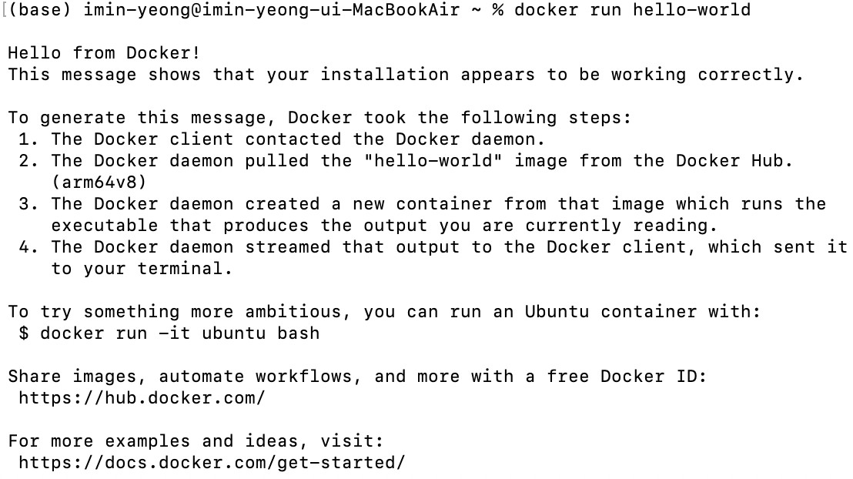

**실습 #2**

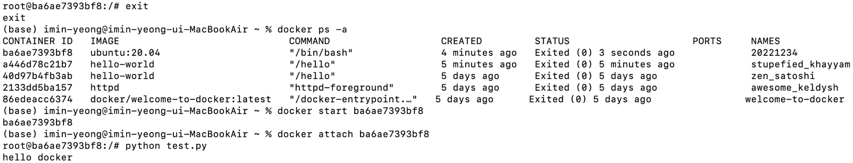

**실습 #3**

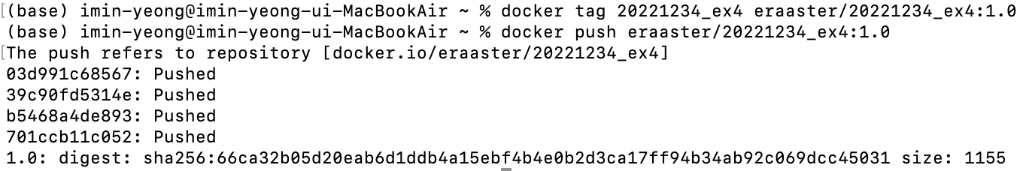

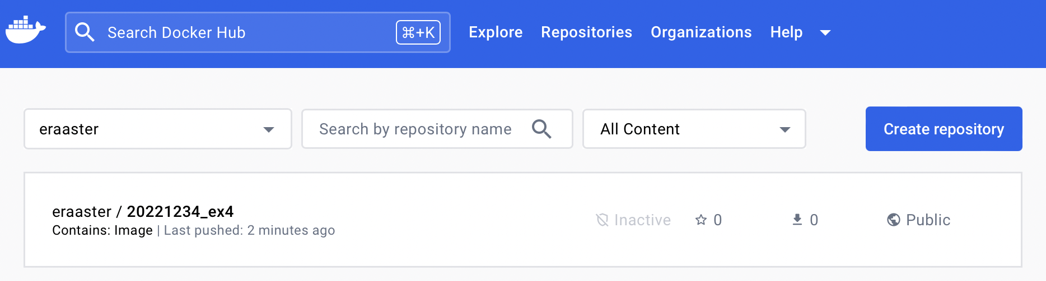

**실습 #4**



**실습 #5**

